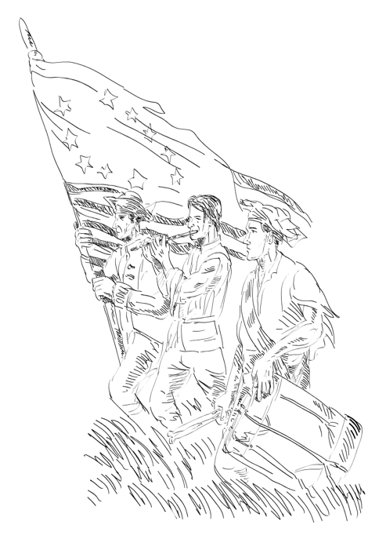
Fraunces Tavern is best remembered as the site of Washington’s Farewell. After the end of the Revolutionary War, Washington decided to retire from the military. On December 4, 1783, Washington and his closest officers gathered for dinner at Fraunces Tavern. It was here that Washington said goodbye to his officers, thanking them for their service. Washington then left the tavern, heading first to Baltimore to resign from the military, and then home to Mount Vernon, Virginia.

How do historians know what happened at Washington’s Farewell? One of the officers present at Fraunces Tavern wrote about it! Benjamin Tallmadge, a soldier and spymaster for General Washington, wrote an account of the farewell in his memoir. This is the only account of the farewell.

Read Tallmadge’s account below. You may be unfamiliar with some of the words, or see words you recognize used in a different way. Check out the Words to Know!

Words to Know

Commence - to begin, to start
Classes commence at 8:30 in the morning.

Repaired - to go to a place, especially with people
We repaired to a restaurant after seeing a movie.

Reciprocated - to give (feelings or things) in return
I gave my friend a birthday present. She reciprocated by giving me a gift on my birthday.

Partaking - to eat or drink together
At the picnic, we will partake in sandwiches and cookies.

Devoutly - sincere, serious
After a week of rain, he devoutly wished for a sunny day.

Suffused - to spread all over
The girls were suffused with laughter while watching the funny movie.

The time now drew near when General Washington intended to leave this part of the country for his beloved retreat at Mt. Vernon. On Tuesday the 4th of December it was made known to the officers then in New York that General Washington intended to commence his journey on that day.

At 12 o’clock the officers repaired to Fraunces Tavern in Pearl Street where General Washington had appointed to meet them and to take his final leave of them. We had been assembled but a few moments when his excellency entered the room. His emotions were too strong to be concealed which seemed to be reciprocated by every officer present. After partaking of a slight refreshment in almost breathless silence the General filled his glass with wine and turning to the officers said, “With a heart full of love and gratitude I now take leave of you. I most devoutly wish that your latter days may be as prosperous and happy as your former ones have been glorious and honorable.”

After the officers had taken a glass of wine General Washington said, “I cannot come to each of you but shall feel obliged if each of you will come and take me by the hand.” General Knox being nearest to the Commander-in-chief who, suffused in tears, was incapable of utterance but grasped his hand when they embraced in silence. In the same affectionate manner every officer in the room marched up and parted with his general in chief. Such a scene of sorrow and weeping I had never before witnessed and fondly hope I may never be called to witness again.

Now that you have read Tallmadge’s account of the farewell, how do you imagine the scene?
.
.

How do you think the officers felt? .
.

What words did Tallmadge use to make you think that? .
.

Tallmadge’s memoir is an example of a primary source. A primary source provides original information. It is created by someone who has direct knowledge of the event being described. Things like diaries, photographs, and letters are primary sources. This is different from secondary sources. A secondary source is created by looking at primary sources. They are created by someone who did not experience the event firsthand, but who studied primary sources. For example: a letter written by George Washington is a primary source. A textbook is a secondary source.

Now that you have read Tallmadge’s memoir, it’s your turn! Write your own account of an event in your life. Keep these things in mind when writing your account:

What might historians in the future want to know about your life?
What words can you use to let people know what happened?
What words can you use to let people know how you felt about what happened?

This program is supported, in part, by public funds from the New York City Department of Cultural Affairs in partnership with the City Council.

