Fraunces Tavern Museum Word Search
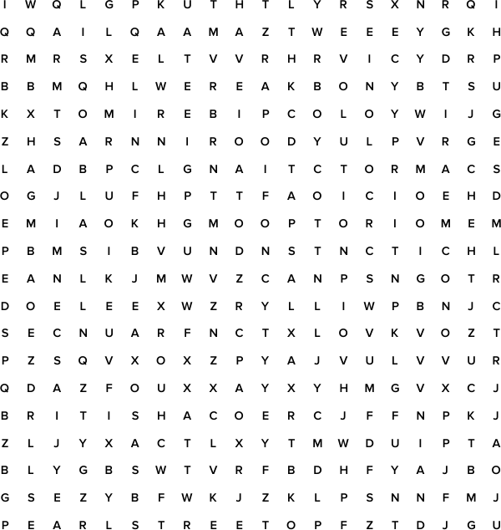

Find the following words associated with the Museum and the American Revolution!

