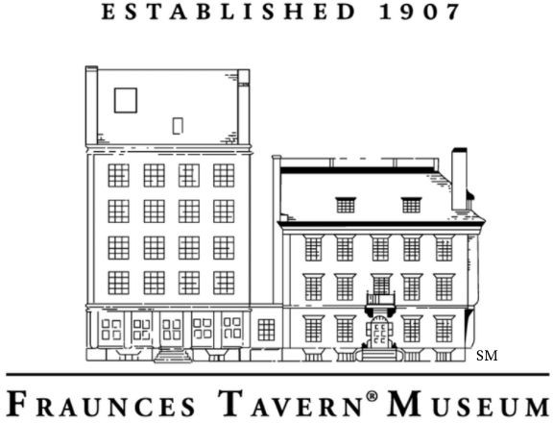

How do we learn about people from the past? One way historians study the past is by looking at primary sources. Primary sources are first-hand accounts of information. They are created by people who have direct knowledge of what they are recording. Examples of primary sources are letters, diary entries, and photographs. Documents written by the people of the past can help us understand what their lives were like. Primary sources documents can be especially helpful to historians when other artifacts, such as the objects used in their daily lives, might be harder to find.

While we do not have any of the objects Samuel Fraunces owned when he operated his tavern, the Museum was able to recreate a room at Fraunces Tavern. The Long Room is interpreted to look like the average 18th century tavern room. Through detailed research, Museum staff was able to piece together what a tavern looked like in the 1700s. But what kind of primary sources did they use?
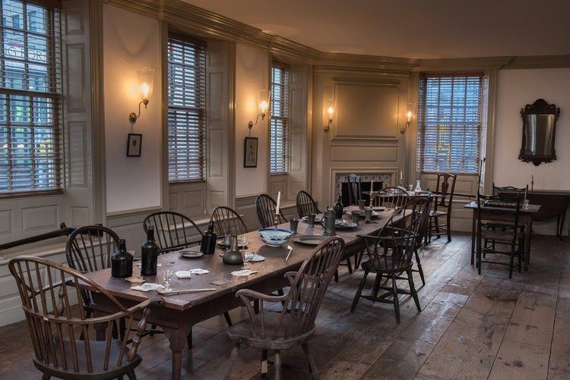
The Long Room at Fraunces Tavern Museum.

Take a look at this selection of items from an inventory of Samuel Fraunces’ possessions. An inventory is a list of items belonging to a person. This primary source document was created in 1795, cataloging all of Fraunces’ possessions after he had moved to Philadelphia. The original inventory was six pages long.

1 large brass kettle 3 barrels of pickles 25 candles
1 Windsor bench
72 Windsor chairs 2 square card tables
3 round wooden tables 10 table cloths
1 silver tea pot
1 large Japanese tea urn 8 punch bowls
7 copper saucepans
3 iron pans
4 cake pans
2 waffle irons
80 pounds of brown sugar 7 green curtains
1 small green carpet 1 silver sugar dish 12 coffee pots
76 packs of cards 9 china dishes

What can this inventory tell you about Samuel Fraunces? What can it tell you about his tavern?

Based on this inventory, describe what you think a room at Fraunces Tavern may have looked like.

Make your own inventory! Use the space below to take an inventory of a room in your home. If a historian looked at your inventory, would they be able to recreate the room? What would they learn about your daily life?

This program is supported, in part, by public funds from the New York City Department of Cultural Affairs in partnership with the City Council.

